UML
MainWindow
-scene: QGraphicsScene *
-world: b2World *
-itemList: QList<GameItem *>
-timer: QTimer
-b1: Bird_red *
-b2: Bird_blue *
-b3: Bird_black *
-b4: Bird_yellow *
-e1: Enemy *
-e2: Enemy *
-restart: QPushButton
-exit: QPushButton
-score: QLabel *
-count: int
-num: int
-s: int
-v1: int
-v2: int
-start_x: float
-start_y: float
-end_x: float
-end_y: float
-kill: bool
-kill1: bool
-skillstatus: bool
+<<explicit>>MainWindow(parent:QWidget *=0): void
+~MainWindow()
+showEvent(QShowEvrnt*): void
+eventFilter(QObject *,event:QEvent): bool
+closeEvent(QCloseEvent*):void
+<<signals>>quitGame(): void
-<<slots>>tick(): void
-<<slots>> QUITSLOT(): void
-<<slots>>restartgame(): void
-<<slots>>exitgame(): void
-init(): void
-game(): void

GameItem
#g_body: b2Body *
#g_pixmap: QGraphicsPixmapItem
#g_size: QSizeF
#g_world: b2World *
#g_worldsize: static QSizeF
#g_windowsize: static QSizeF
+GameItem(world:b2world *)
+~GameItem()
+setGlobalSize(worldsize:QSizeF,windowsize:QSizeF): static void
+<<slots>>paint(): void

Land
+Land(x:float,y:float,w:float,h:float,pixmap:QPixmap,world:b2World *,scene:QGraphicsScene *)

Arrow
+Arrow(x:float,y:float,w:float,h:float,pixmap:QPixmap,world:b2World *,scene:QGraphicsScene *)

Wood
+Wood(x:float,y:float,w:float,h:float,pixmap:QPixmap,world:b2World *,scene:QGraphicsScene *)

Enemy
+Enemy(x:float,y:float,radius:float,timer:QTimer*,pixmap:QPixmap,world:b2World *,scene:QGraphicsScene *)
+getLinearVelocity(): b2Vec2

Bird
+Bird(x:float,y:float,radius:float,timer:QTimer *,pixmap:QPixmap,world:b2World *,scene:QGraphicsScene *)
+setLinearVelocity(velocity:b2Vec2): void
+setAngularVelocity(angla:float): void
+skill(): virtual void

Bird_black
+Bird_black(x:float,y:float,radius:float,timer:QTimer *,pixmap:QPixmap,world:b2World *,scene:QGraphicsScene *)
+skill(): virtual void

Bird_red
+Bird_red(x:float,y:float,radius:float,timer:QTimer *,pixmap:QPixmap,world:b2World *,scene:QGraphicsScene *)
+skill(): virtual void

Bird_yellow
+Bird_yellow(x:float,y:float,radius:float,timer:QTimer *,pixmap:QPixmap,world:b2World *,scene:QGraphicsScene *)
+skill(): virtual void

Bird_blue
+Bird_blue(x:float,y:float,radius:float,timer:QTimer *,pixmap:QPixmap,world:b2World *,scene:QGraphicsScene *)
+skill(): virtual void

遊戲畫面
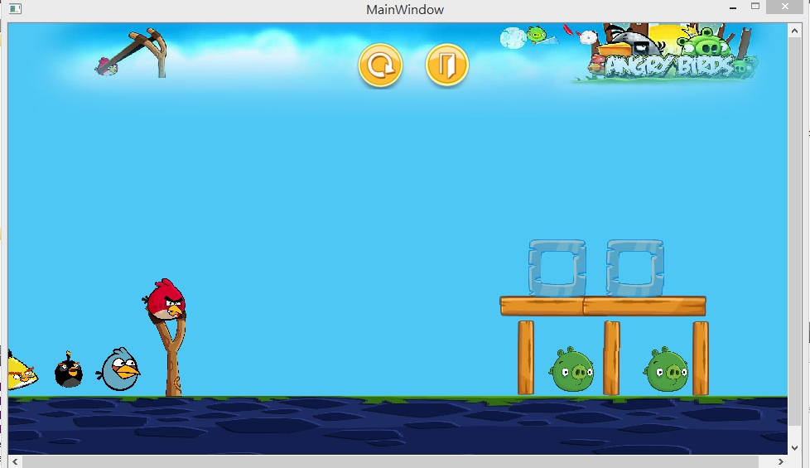
按Z，換藍色鳥發射
按A，藍色鳥的技能
按X，換黑色鳥發射
按S，黑色鳥的技能
按C，換黃色鳥發射
按D，黃色鳥的技能
如果豬的x方向速度在5~15之間，分數連續加100分
如果超過15，得5000分，且豬死亡消失

